DIGITAL IMAGE PROCESSING (CS517)

ASSIGNMENT 3 REPORT (JPEG Encoder and Decoder)

SAZID ALI – 2022AIM1013

1. **JPEG Encoder/Decoder**

**Analysis of JPEG Encoding by a varying number of components (DC coefficients)**

Example: 1

**Block size = 8**

I fixed the block size as 8x8 and the varied number of components per block.

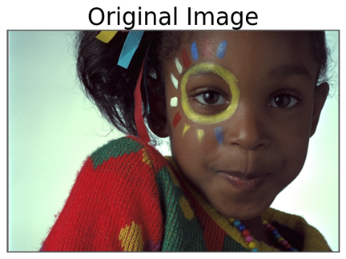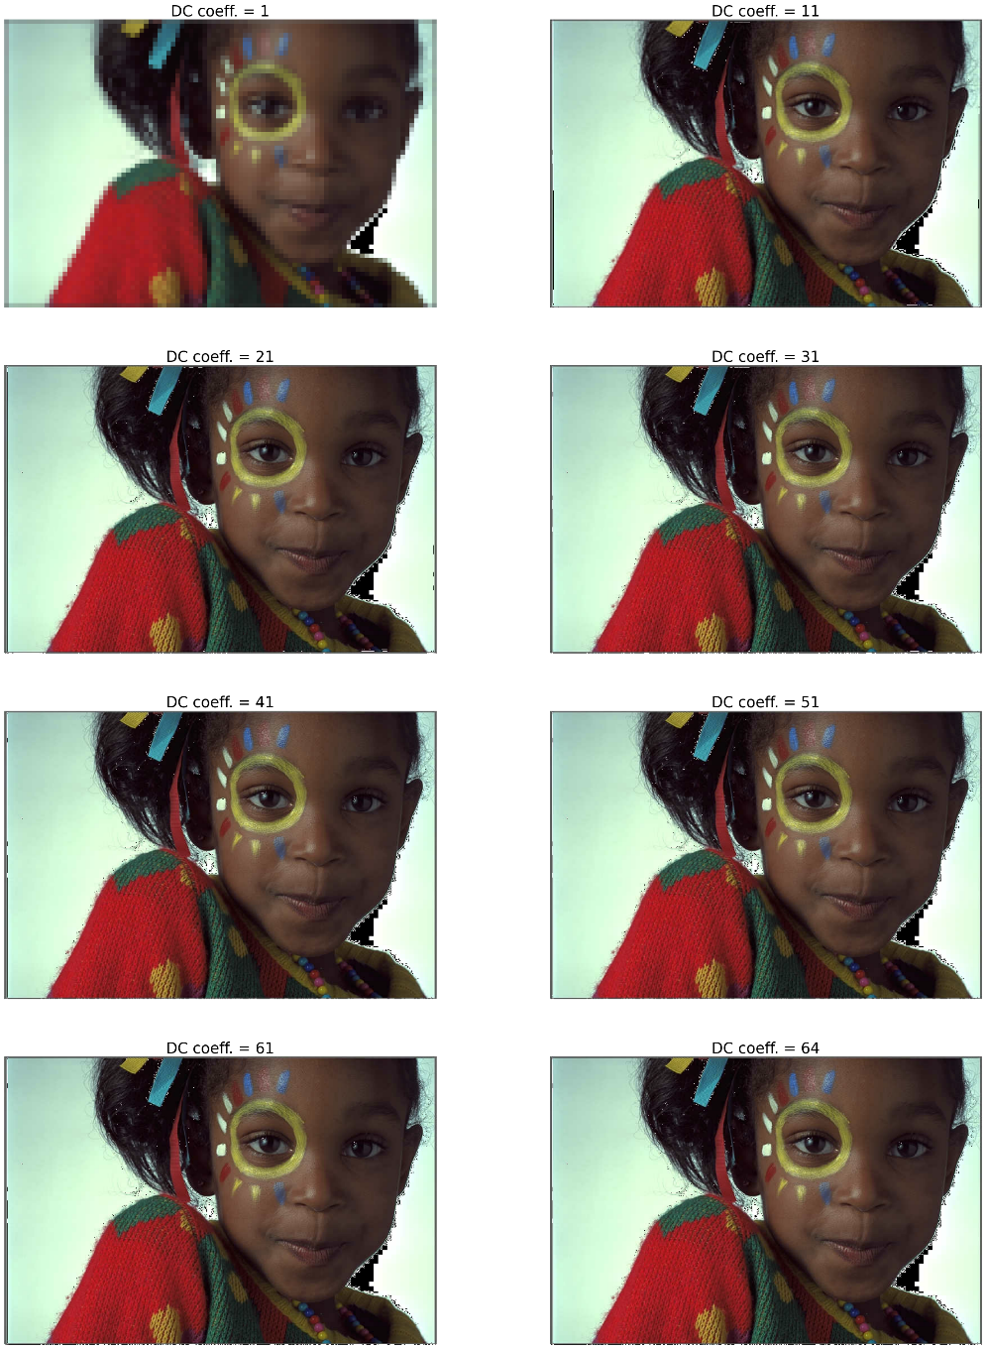

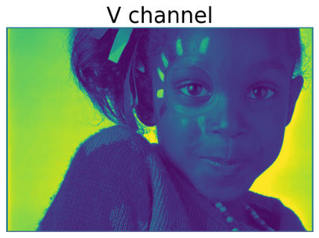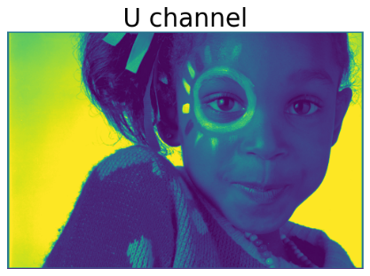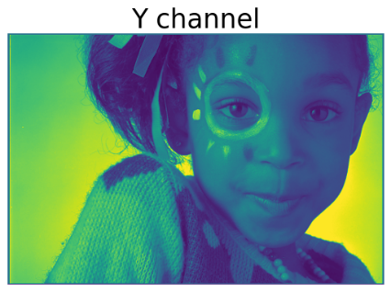

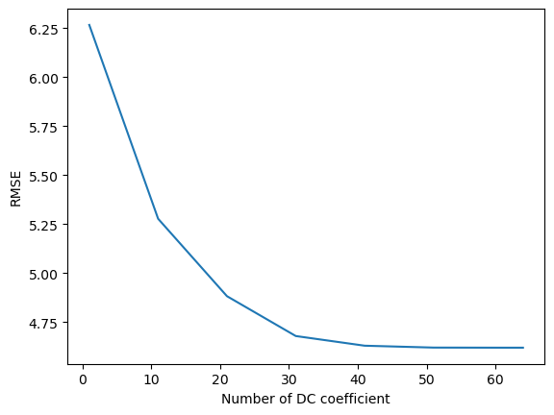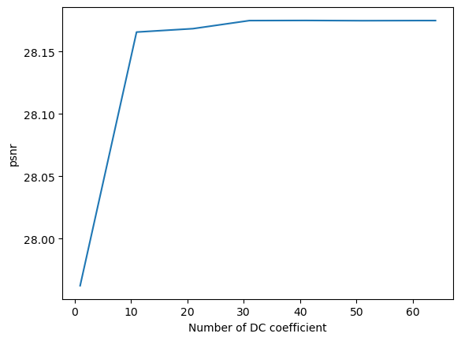

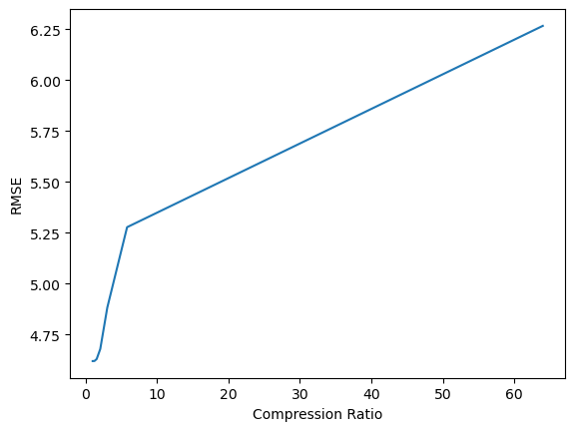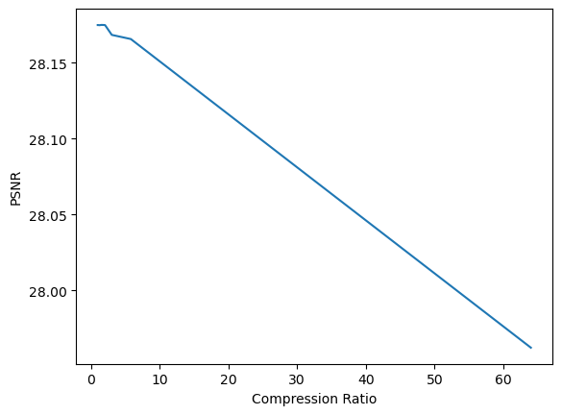

**Observation:**

1)For the above image, we can observe that when the number of components per block is increased then RMSE for the JPEG decoded image is decreasing.

2) PSNR value increased with the increasing number of components per block. A high PSNR value means that the image quality is closer to the original image.

3) When the compression ratio is high then the PSNR value is also high. A high compression ratio means that more number of bits are used to encode the image. With the increase in compression ratio, image quality is also degraded and the PSNR value is also decreased.

4) With the increase in compression ratio, image quality is decreasing and RMSE error will also increase.

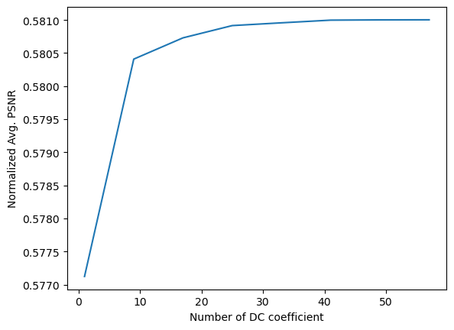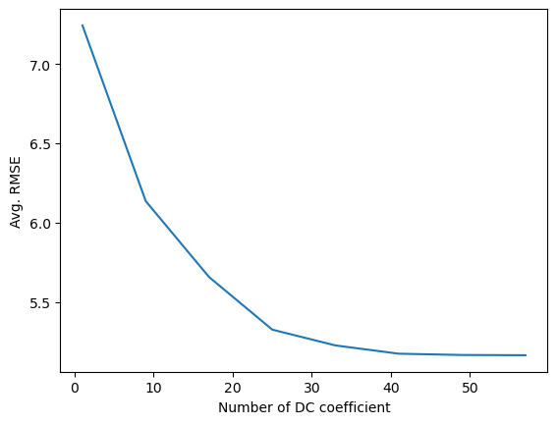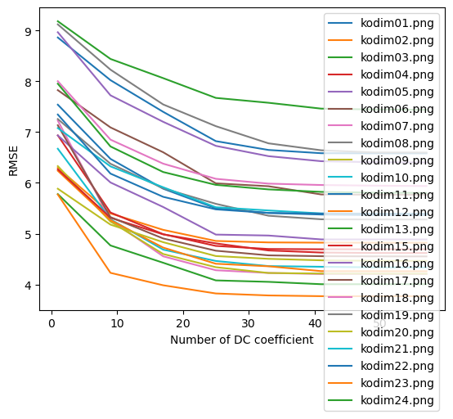

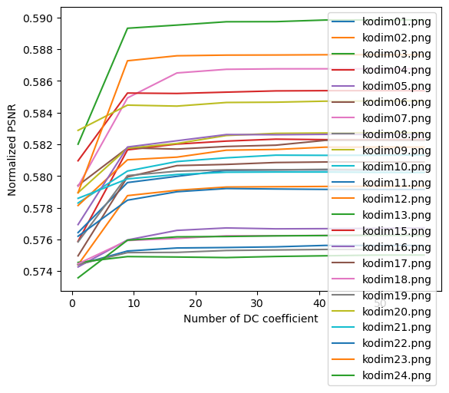

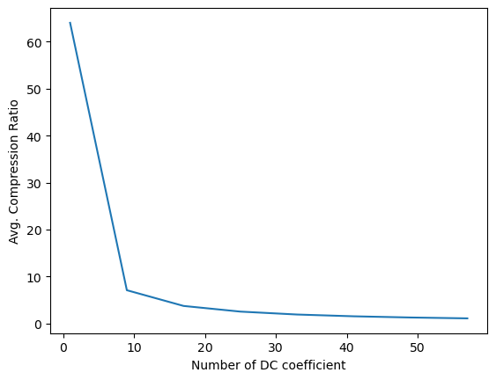

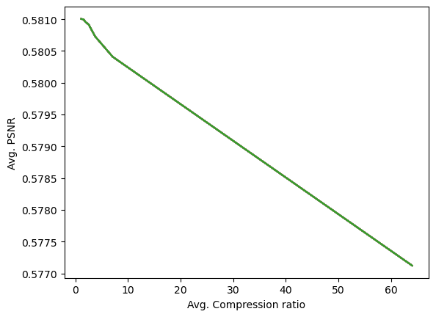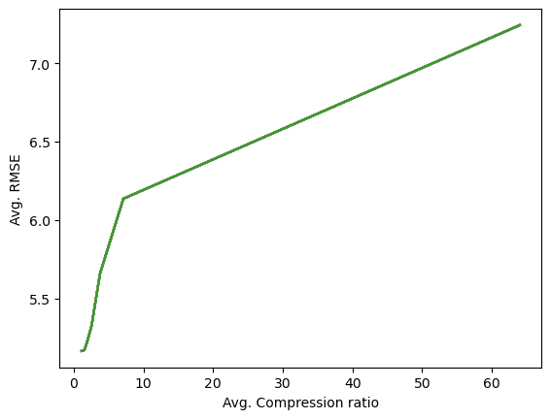**Analysis of JPEG Encoding by varying sizes of blocks(DC coeff. = 1)**

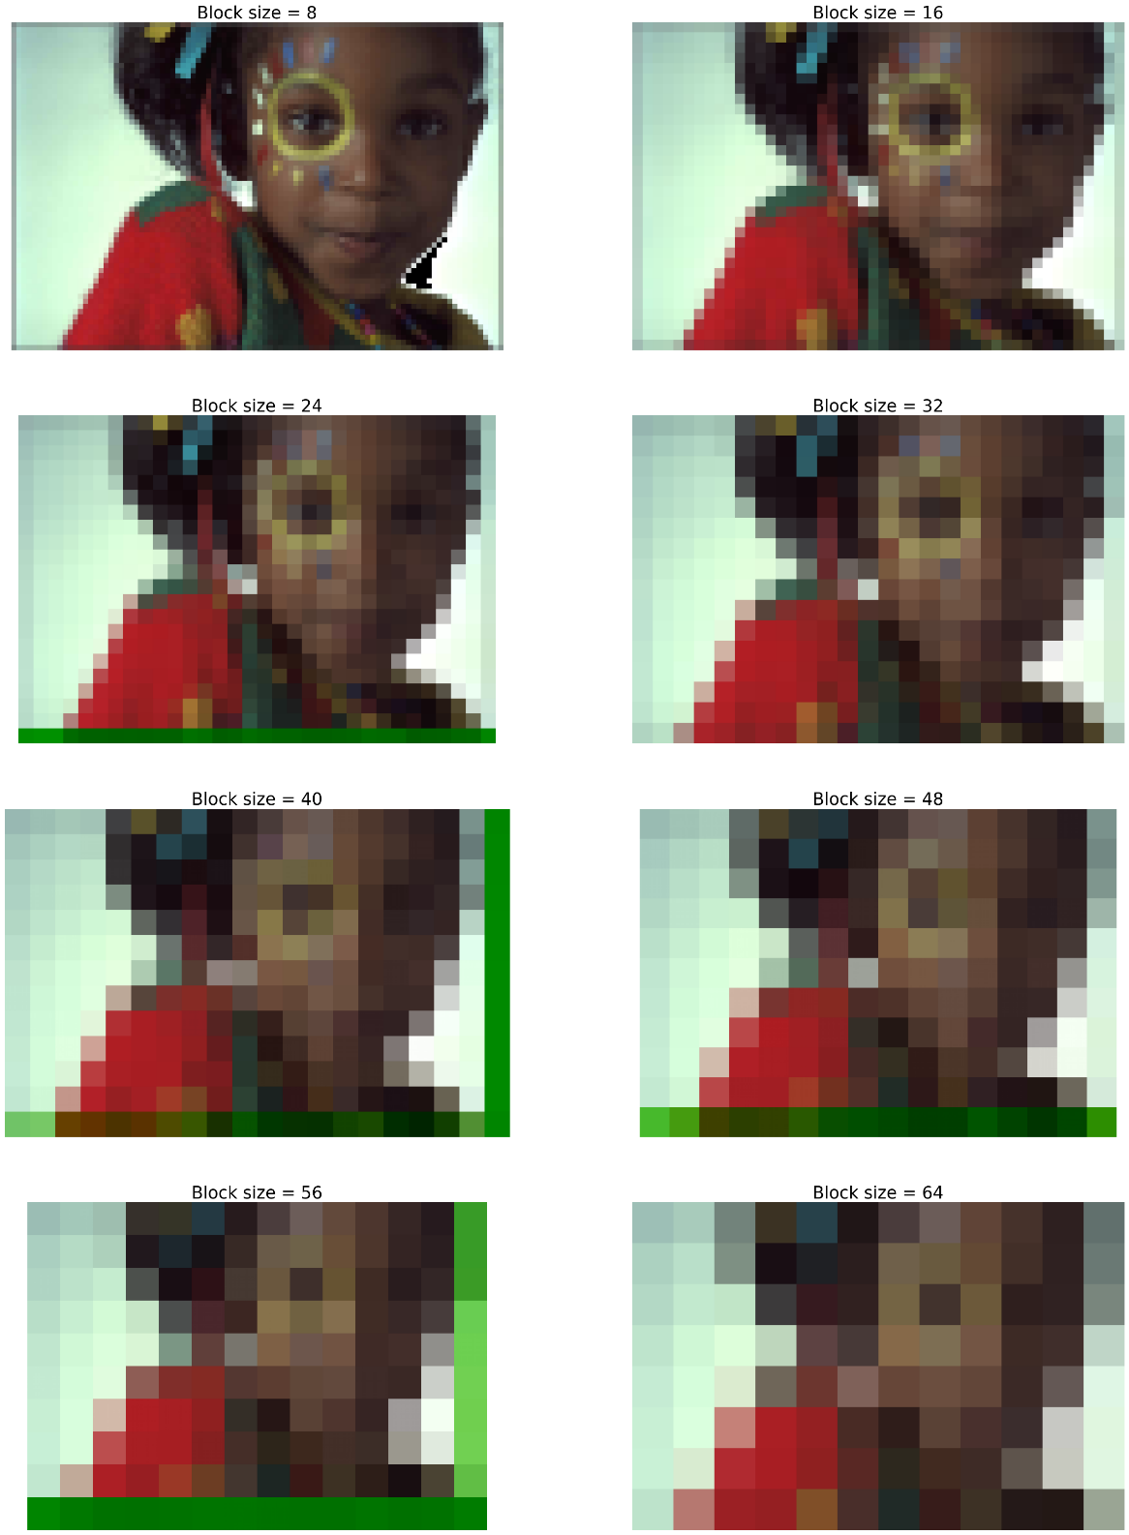

|  |  |  |
| --- | --- | --- |
| **Block size** | **Q Matrix (Y)** | **Q Matrix (U & V)** |
| **8** |  |  |

|  |  |
| --- | --- |
| **Block Size** | **Q Matrix (Y)** |
| **16** |  |
|  | **Q Matrix (U & V)** |
|  |  |

**Block size VS RMSE**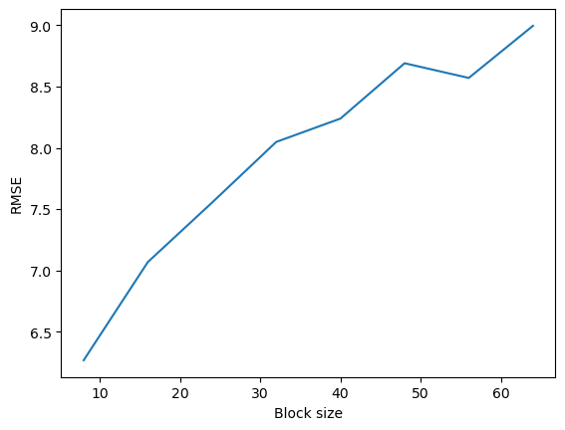

**Observation:** Taken DC coeff. = 1

As the size of the block increases, RMSE error increases because more pixels represented by only 1 DC coeff.

**Block size vs PSNR**

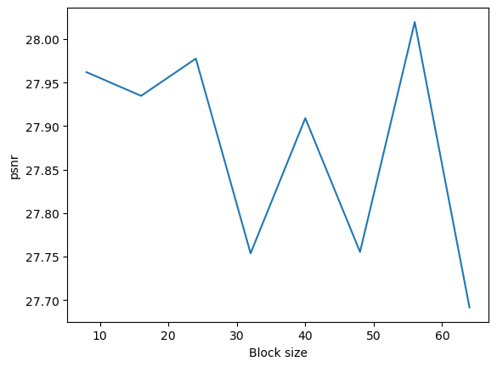**Observation:**

As the size of the block increases, the PSNR value decreases because the quality of the image decreases because more pixels is represented by 1 DC coeff.

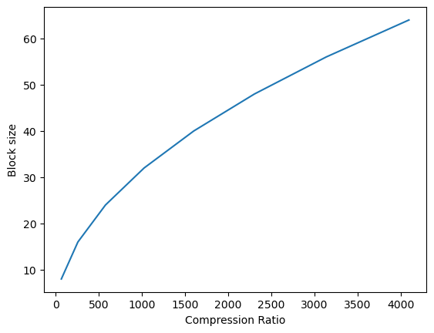 **Block size vs Compression ratio**

**Observation:**

With the increase in the size of the block size, the compression ratio also increases. Less number of components is required for each block.

**Compression ratio vs RMSE**

**Observation:**

A high compression ratio means a lower number of encoded codes for images due to which image quality decreases and RMSE error increases.

**Compression ratio vs PSNR**

**Observation:**

A high compression ratio decreases the quality of the image due to which PSNR also decreases.

